The Symbiosis of Casualty and Religion: Re-functioning the Ancient Pagodas

Abstract
This essay investigates how ancient Buddhist pagodas in urban China can be re-envisioned to integrate spirituality into daily life, reconciling sacredness with modern informality. It examines the evolving role of religious architecture, particularly how young people engage with ritual and symbolism in casual, contemporary ways. Through a design proposal inspired by the Yingxian Pagoda’s geometrical hierarchy, this study emphasizes spatial strategies—such as descending zones and octagonal spaces—that enable a harmonious balance between sacred and secular functions. The proposal aims to resolve conflicts between the pagoda’s traditional spiritual significance and the dynamic social practices of younger generations, promoting a civic identity that reflects both cultural heritage and contemporary urban needs. This research concludes that thoughtfully re-functioned pagodas can serve as vibrant urban landmarks fostering spirituality within everyday experiences.

Keywords: Buddhist pagodas, religious architecture, spirituality, urban design, sacred and secular integration, Yingxian Pagoda, spatial hierarchy, contemporary Chinese society

1 Introduction

1.1 Background
Contemporary China is experiencing unprecedented urbanization and modernization, processes which have profoundly transformed not only its built environment but also its social fabric and the patterns of daily life [1]. Traditional sacred spaces, such as pagodas and temples, once functioned as central nodes for spiritual practice, social cohesion, and cultural identity, playing a critical role in shaping communal values and shared experiences [2]. These architectural forms not only provided physical sites for religious rituals and ceremonial activities but also embodied complex cosmological ideas, moral principles, and collective historical memory. They served as tangible expressions of belief systems, cultural continuity, and social organization, acting as prominent landmarks and reference points within the communal landscape.
However, in modern urban contexts, these structures are increasingly marginalized and often overlooked in urban planning and development. Rapid urban expansion, intensified land-use pressures, and the prioritization of commercial and functional considerations frequently result in traditional sacred buildings being underutilized, isolated, or treated primarily as heritage or tourist sites. Modern architecture emphasizes efficiency, functionality, and economic value, often neglecting the symbolic, spiritual, and cultural dimensions that historical buildings inherently provide [3]. Consequently, while pagodas continue to hold significant cultural and historical importance, their function as active centers for spiritual engagement has steadily declined, creating a pressing and urgent challenge for architects, urban planners, and cultural preservationists in terms of maintaining their relevance and ensuring that these sacred spaces continue to contribute meaningfully to contemporary social and spiritual life [4].

1.2 Literature Review
Urban life today is highly dynamic, fast-paced, and diverse, shaped by rapid social, technological, and economic changes [5]. Residents face increasingly complex daily routines, balancing work, education, social engagements, and leisure activities. In this context, formal religious participation has declined, especially among younger generations, who are less likely to engage in traditional rituals or attend religious services regularly [6]. Spirituality and religious experiences have gradually shifted toward informal and personalized forms, such as mindfulness practices, meditation, or casual communal gatherings. Instead of being confined to ritualized events or sacred spaces, spiritual engagement is now embedded within everyday life, reflecting the need for flexible and accessible ways to fulfill personal and communal spiritual needs [7, 8].
Consequently, traditional pagodas, which historically functioned as active centers for religious activity, community gathering, and cultural expression, are increasingly treated as heritage sites or tourist attractions [9]. While their symbolic and spiritual significance is still recognized, their role as spaces for reflection, personal growth, or social interaction has diminished. This transformation highlights a broader tension in modern urban life: the cultural and symbolic values of sacred architecture are acknowledged, yet they no longer align with the practical needs, lifestyles, and expectations of contemporary city residents. Many pagodas, therefore, remain isolated within urban landscapes, physically separated from the areas where daily social and cultural activities occur, which further limits their functional and spiritual relevance [10, 11].
The gap between traditional sacred architecture and modern urban life presents challenges for both heritage preservation and urban design [12, 13]. The physical isolation and functional underutilization of pagodas reduce their potential to contribute meaningfully to urban social and cultural experiences. Additionally, their spiritual and symbolic values, deeply rooted in historical cosmology and belief systems, are often abstract and less accessible to secular populations. This situation highlights the need to reimagine pagodas not merely as historical monuments but as adaptable urban spaces capable of supporting everyday social, cultural, and spiritual activities [14]. By integrating sacred architectural principles with contemporary urban requirements, it is possible to create multifunctional spaces that preserve cultural continuity while enhancing relevance and accessibility for modern urban residents.

1.3 Limitations and Research Focus
Despite their historical significance, traditional pagodas face multiple limitations in addressing contemporary urban needs. They are often spatially isolated and lack multifunctional capabilities, making it difficult to incorporate them into everyday social and cultural life. The spiritual and symbolic values they carry are increasingly abstract, limiting their accessibility and resonance for a largely secular population. Moreover, contemporary urban planning and architectural design seldom draw on the cosmological, symbolic, and spiritual principles inherent in traditional pagodas, resulting in a disconnect between heritage conservation and modern functionality.
This research aims to bridge these gaps by exploring how traditional pagodas, as embodiments of Buddhist cosmology and spiritual values, can be reimagined and adapted to contemporary urban contexts. By examining both historical pagodas and modern urban open spaces, the study seeks to develop architectural strategies that:
- Retain and reinterpret symbolic and spiritual values in ways that resonate with contemporary society;
- Integrate daily social, cultural, and communal activities within the architectural framework;
- Transform the principles of sacred architecture into multifunctional, accessible, and inclusive urban design solutions.
By adopting this approach, the study demonstrates how spiritual and cultural values can be embedded in functional modern spaces, enriching urban life while preserving historical and cultural continuity. Ultimately, this research contributes to the dialogue between heritage and innovation, showing that sacred architecture can evolve to meet contemporary societal demands without losing its essential symbolic and spiritual essence.

2 Meaning of Religious Architecture

2.1 The Symbolic and Cultural Meaning of Religious Architecture
Religious architecture has historically extended far beyond its physical form or structural composition. Buildings such as pagodas, churches, and mosques functioned as vessels of spiritual meaning, moral values, and community cohesion. They embodied the cosmological principles and theological worldviews that shaped their respective belief systems. In earlier societies, these forms were carefully crafted to inspire awe, guide ritual practices, and anchor a community’s sense of identity and belonging. Their spatial hierarchies, material selections, and aesthetic principles were not arbitrary; instead, they were deeply intertwined with symbolic narratives and metaphysical interpretations of the universe. Figure 1 depicts a Buddhist sacred site that gathers devoted practitioners of the faith. In this sense, religious architecture functioned not only as a physical shelter or ritual site, but also as a cultural archive that preserved collective memory and transmitted values across generations.
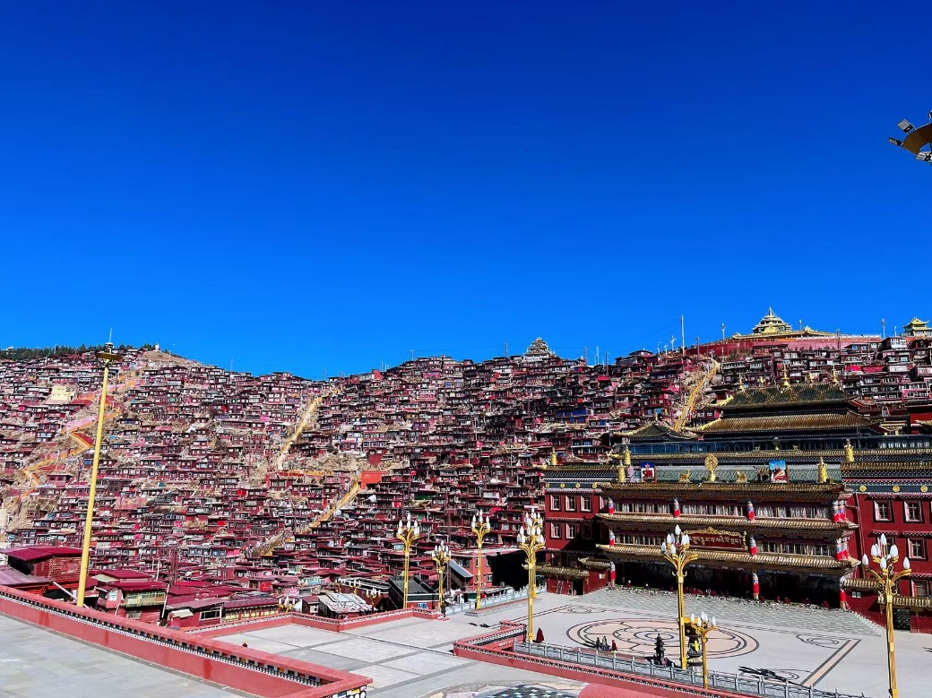
Figure 1. Sertar, a sacred Buddhist site

2.2 The Impact of Urbanization and Modern Functionalism
However, with the rapid acceleration of urbanization and modernization, the role of religious architecture has been significantly challenged. Contemporary city planning often prioritizes efficiency, flexible usage, and economic productivity, resulting in architectural forms that emphasize practicality over symbolic richness. As cities densify, there is a growing tendency to obscure or downplay the religious connotations embedded in traditional architectural works. Structures that once carried cosmological significance are increasingly evaluated through the lens of secular utility, leading to a partial abandonment of their original ceremonial and spiritual purposes. Traditional religious buildings frequently become isolated in dense urban landscapes—treated as heritage relics, tourist destinations, or aesthetic landmarks rather than as active spiritual centers. This shift reflects a broader cultural transformation in which symbolic and ritualistic values are overshadowed by economic and functional imperatives.

2.3 Contemporary Societal Desire for Ritual and the Challenges for Design
Despite these transformations, the human desire for ritual, symbolism, and spiritual experience remains persistent. Younger generations may be less inclined to participate in formal religious institutions, yet they often maintain an informal engagement with spirituality. Many individuals continue to seek symbolic or ceremonial moments in everyday life—such as visiting temples, attending church weddings, burning incense for good fortune, or seeking quiet spaces for meditation and reflection. For example, Figure 2 includes both tourists and religious devotees. These subtle forms of engagement indicate that the experiential dimensions provided by religious spaces remain culturally relevant, even if traditional doctrines are not strictly followed.
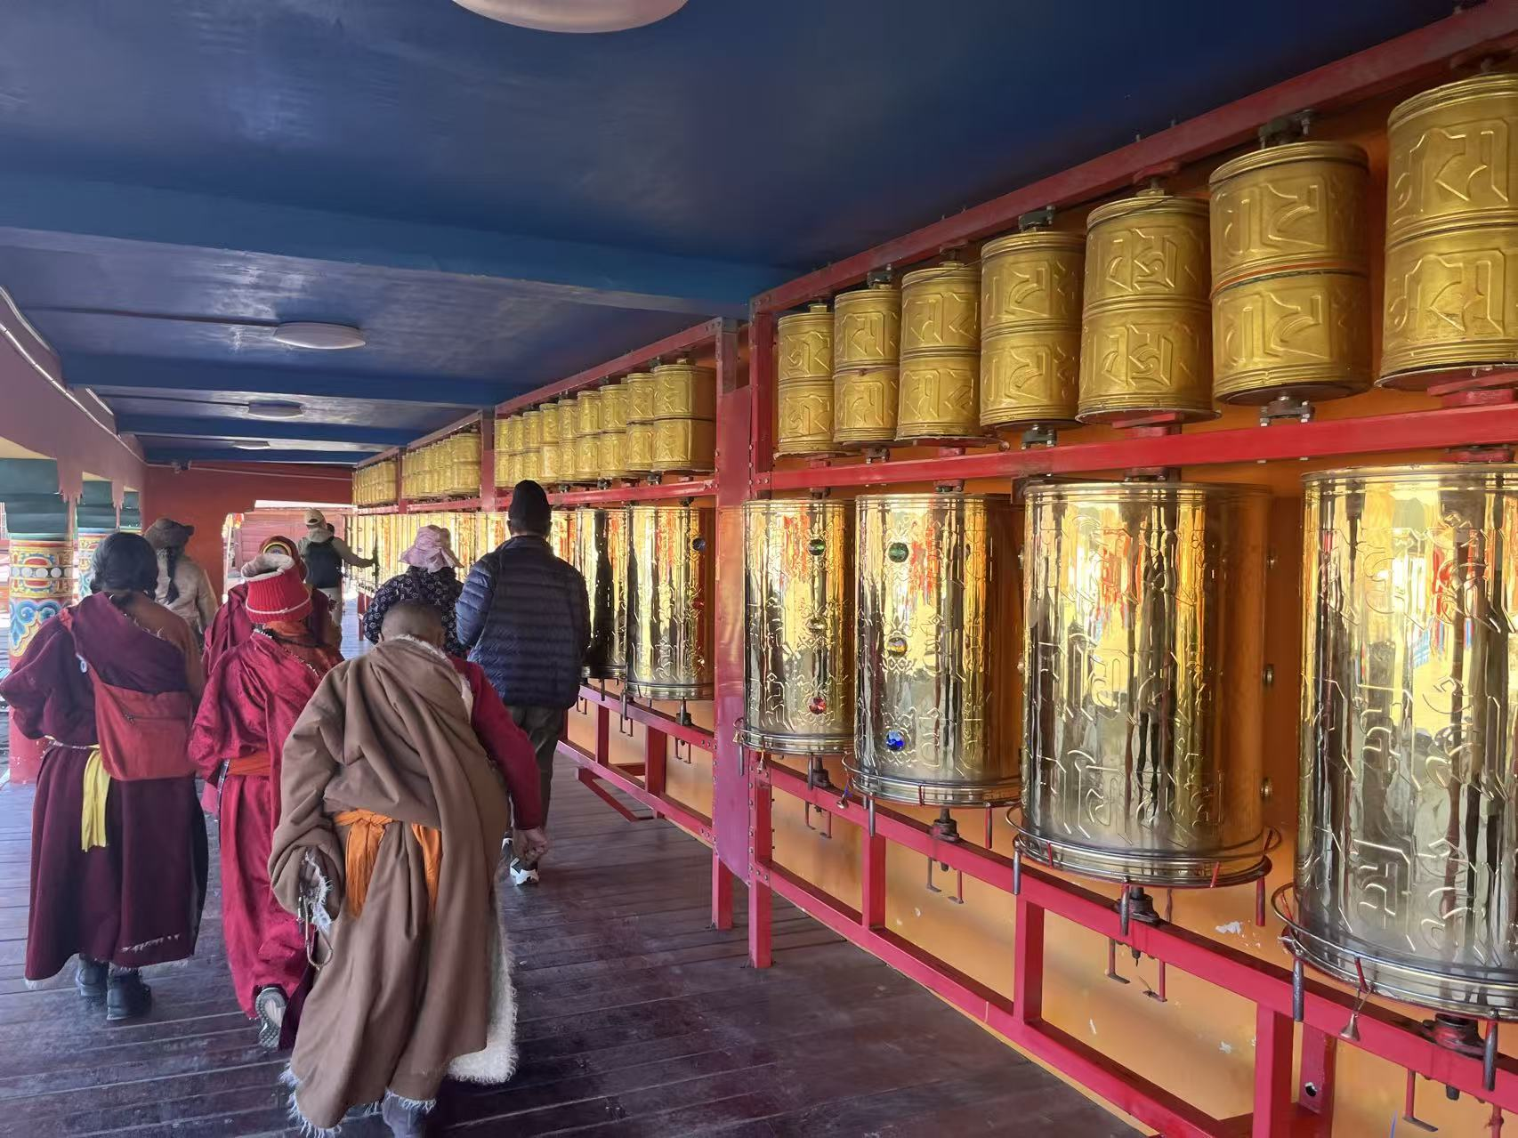
Figure 2. Tourists and believers
This enduring desire for meaningful ritual presents a complex challenge for architects and urban planners. Designing contemporary spaces requires a balance between maintaining accessibility for modern, multifunctional urban use and preserving the symbolic qualities that enable users to experience a “sense of ceremony.” Architectural solutions must therefore explore new ways of integrating ritualistic spatial sequences, atmospheric qualities, and symbolic references without relying solely on traditional religious forms. The task is not to replicate historical sacred architecture, but rather to reinterpret its essence so that spiritual engagement can coexist with contemporary lifestyle patterns and urban constraints.

3 The Contemporary Demand for Everyday Religiosity

3.1 Fluidity and Personalization in Contemporary Religiosity
In modern society, religious engagement has become increasingly fluid, individualized, and detached from rigid institutional frameworks. Instead of participating in highly structured rituals or adhering to strict doctrinal systems, many people—especially younger generations—approach spirituality through flexible, personalized practices that align with their lifestyles. This shift reflects a broader cultural preference for accessibility, inclusivity, and emotional resonance over traditional forms of religious discipline.
In contemporary urban China, this trend is particularly pronounced. Young visitors often travel to Buddhist temples not primarily for formal worship, but for sightseeing, aesthetic appreciation, or emotional comfort. They may light incense, make simple wishes, or engage in brief moments of reflection, yet rarely follow the full ritual customs or doctrinal expectations associated with Buddhist practice. Figure 3 shows Mount Laojun, a famous scenic site where many people come to burn incense and visit for leisure. As a result, spirituality becomes integrated into everyday life: a casual temple visit during a weekend trip, a prayer before exams, or a moment of quiet reflection while passing a shrine.
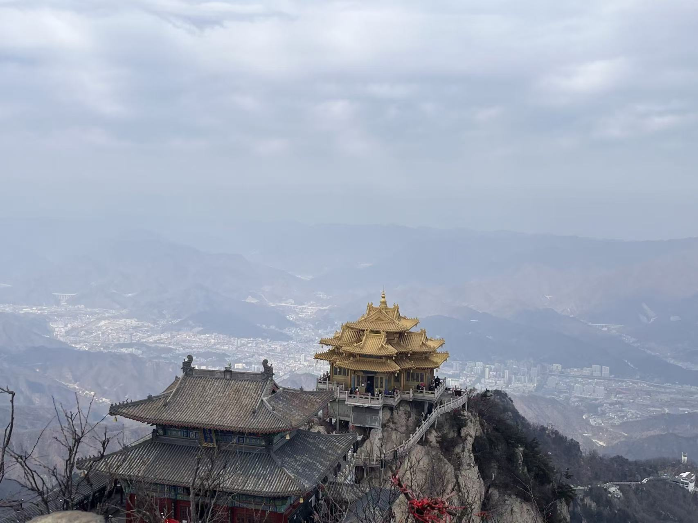
Figure 3. The combination of tourist attractions and temples
This blending of sacred and secular behaviors challenges traditional conceptions of Buddhist cosmology and ritual space. The boundaries that once separated religious practice from daily experience are progressively dissolving, leading to a new form of “everyday religiosity” that is informal, experiential, and deeply intertwined with contemporary urban lifestyles.

3.2 Architectural Challenges and Opportunities in Supporting Everyday Spirituality
The integration of religious expression into ordinary daily activities creates an urgent need for architectural forms that can accommodate this duality. Instead of maintaining a strict separation between sacred and secular spaces, contemporary design must recognize the coexistence of both dimensions in the modern individual’s spiritual life. This expands the role of architecture from merely hosting ritual events to shaping atmospheres and environments that support subtle, informal spiritual experiences.
This shift also presents new opportunities. Rather than designing exclusive religious spaces reserved for formal worship, architects can explore hybrid environments that spiritualize everyday behaviors—offering moments of tranquility, reflection, or symbolic meaning embedded within public spaces. Such environments enable users to engage with spirituality on their own terms, without the pressure of institutional expectations or ritual obligations.
Within this context, the Buddhist pagoda becomes a particularly compelling architectural reference. Its rich cultural history, symbolic geometries, and layered spatial meanings offer a powerful foundation for reinterpreting spiritual space in contemporary settings. The pagoda’s unique blend of verticality, symbolism, and ritual pathway provides insights into how sacredness can be expressed architecturally without relying on traditional religious programs. By reimagining the pagoda in a modern, multifunctional form, designers can develop spaces that maintain spiritual resonance while simultaneously supporting diverse, secular urban activities.

4 Why the Pagoda?

4.1 The Pagoda in Urban China
China is a country with a rich and diverse cultural heritage, home to numerous Buddhist pagodas that span different historical periods and regional styles. These architectural works are celebrated not only for their striking geometric hierarchies and structural rigor but also for the profound spirituality and cosmological principles they embody through design. Unlike other religious buildings, which may serve multiple purposes such as residences, community centers, or administrative spaces, pagodas are typically dedicated almost exclusively to religious functions, emphasizing their distinct spiritual and symbolic significance.
In contemporary urban environments, the presence of these historically sacred structures can sometimes create tensions with the demands of modern social life, especially among younger generations whose daily routines and social habits prioritize secular, recreational, or commercial activities. This contrast raises important questions about the relevance and adaptability of pagodas today. It becomes crucial to understand not only how pagodas establish and communicate their sense of spirituality but also how these spiritual qualities can be thoughtfully integrated into modern urban life, contributing simultaneously to social activities, community identity, and cultural continuity.

4.2 Symbolism and Spatial Traits
As discussed in the previous case studies on specific pagodas in China, it is clear that pagodas are deeply intertwined with Buddhist cosmology and philosophical concepts. Even their seemingly simple forms often reflect specific doctrinal ideologies. The architectural hierarchy of the pagoda—progressing from a broad, solid base to a narrower, elevated top layer—represents a spiritual gradient, guiding both movement and focus for practitioners. This vertical progression mirrors the Buddhist concept of self-development and enlightenment, emphasizing the journey from foundational learning to higher spiritual attainment. For example, Figure 4 illustrates the typical features of a pagoda.
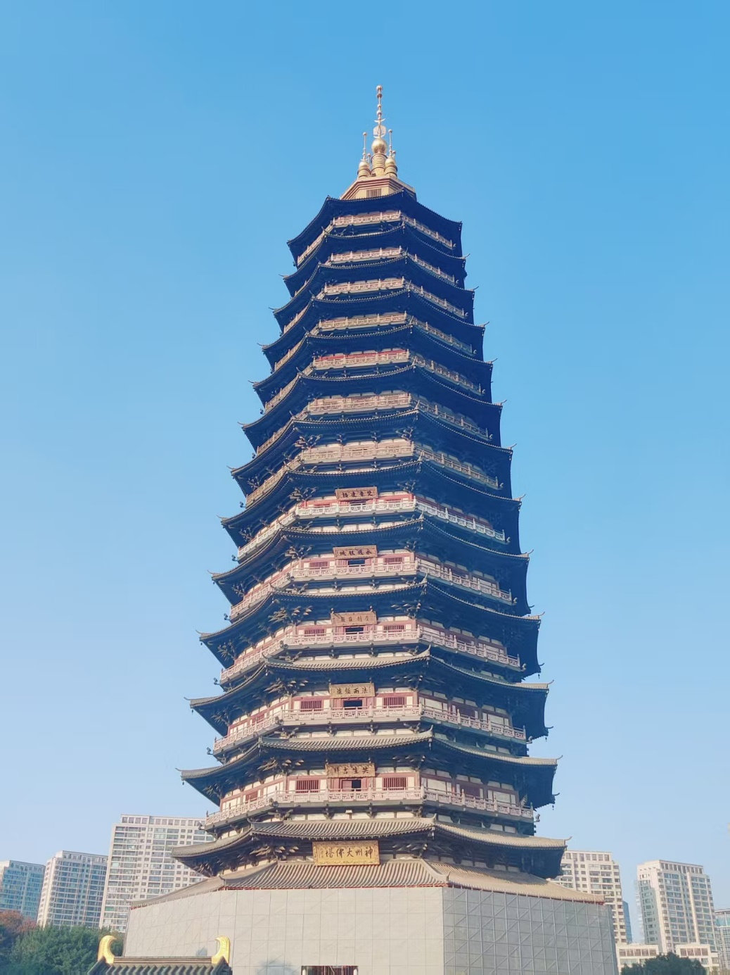
Figure 4. Pagoda
The spatial logic of pagodas—the sequencing of levels, internal chambers, stairways, and surrounding courtyards—is fundamental to the creation of their spiritual atmosphere. Layering, elevation, and gradual progression through space are deliberate design strategies that generate a sense of ascension, contemplation, and focus. Studying these spatial traits is therefore essential for understanding how architectural elements can foster spiritual experience and how these principles might be translated into contemporary, multifunctional contexts while retaining symbolic potency.

4.3 Critique of Prior Adaptations
Previous attempts to adapt religious architecture for contemporary use have often faced significant challenges. In some cases, sacredness was diminished due to over-aestheticization—emphasizing visual appeal at the expense of ritual or symbolic meaning. In others, essential spatial rules that give the structure its religious significance were neglected, resulting in spaces that felt secularized or disconnected from their original spiritual purpose.
The central challenge lies in preserving the ontological and symbolic essence of the pagoda while integrating it into the rhythms of modern urban life. Achieving this balance requires careful attention to both form and function: maintaining the architectural and symbolic features that communicate spiritual meaning, while introducing new programs, social interactions, or civic functions that resonate with contemporary users. Successfully navigating this balance offers a pathway to rejuvenating pagodas as living, relevant spaces that continue to foster spiritual reflection, cultural identity, and community engagement in the modern city.

5 Methodology: Case Study Analysis and Participatory Design

5.1 Case Study Analysis: Geometric Proportion and Symbolism
A detailed analysis of the historical pagodas in China can reveal the sophisticated use of geometric knowledge and their impact on the sense of spirituality of the architecture. Generally, through research on several Chinese pagodas, the use of square root of 2 ratio—seen from the relationship between the side of a square and its diagonal— is a recurring pattern and strategy. This ratio both holds the relationship between the height and width of the pagoda and highlights the ancient Buddhism cosmological concept of self-development.
For example, the Ying Xian Wooden Pagoda, constructed in 1056, is the tallest wooden pagoda among the entire globe. It contains an octagon shape, with double barrel structure, and uses mortise and tenon joints. With great geometric precision, the pagoda’s height-base ratio is around 2√2 proportion. Its layered geometry, with a square shaped base, an octagon body, and a circular top shows the spirituality of ascent from earth to heaven that is vital in Buddhism cosmology. Its use of precise geometric measurements, recurring shapes and patterns all contributes to the overall sacred character of the pagoda.
The Miaoying Temple White Pagoda, constructed in Yuan dynasty is another example of precise geometric relationship. This pagoda has a three-tiered base, a bowl-shaped body, and a conical spire with 13 rings arranged with careful attention to symmetry and geometric proportion. The lotus throne, the upturned petals, and the iron hoops around not only decorates the pagoda aesthetically, but also serves as a change between the structural elements. Geometrically, a spatial hierarchy between the different layers of the pagoda can be easily identified. Specifically, from the base to the top, the layers all turned out a decrease in space and scale. Thus, this gradual decrease in spatial hierarchy contributes to the overall sacredness of the pagoda.

6 Design Process: From Research to Spatial Reconfiguration

6.1 Symbolic Translation and Spatial Planning
The design proposal consciously retains the pagoda’s inherent spatial hierarchy and monumental scale, emphasizing the descending sequence of spaces and differentiated functional zones. By carefully organizing these zones, the design preserves the spiritual significance of vertical progression while accommodating diverse contemporary activities. The use of octagonal shapes in both the spatial layout and ceiling design draws inspiration from the Ying Xian Pagoda, creating transitional spaces that seamlessly integrate sacred and secular functions. These octagonal spaces serve as buffers between areas of contemplation and areas of social interaction, allowing users to experience a gradual shift in atmosphere that subtly reinforces a sense of sacredness within everyday activities.
Symmetry is another crucial element in the design. Each space, particularly at the entrance, employs symmetrical layouts and proportional relationships that evoke a sense of order, balance, and seriousness, subtly encouraging mindfulness and reflection during routine activities. This spatial rigor contributes not only to aesthetic coherence but also to the overall spiritual ambiance of the proposal.
The multifunctional nature of the design is further emphasized by the flexibility of individual spaces. Rooms are programmed to accommodate a variety of daily activities—shopping, entertaining, reading, studying, or informal social interactions—depending on the specific arrangement and use at a given time. By doing so, the design supports both social functions and public amenities, transforming traditional religious spatial principles into a contemporary, community-oriented context.
Overall, by carefully considering geometric relationships, spatial hierarchy, and social functionality, the proposal establishes a mediated environment that bridges sacred and secular realms. It offers a design framework that preserves spiritual qualities while simultaneously adapting to the rhythms and needs of modern urban life, demonstrating that religious architectural principles can inform multifunctional contemporary spaces without losing their symbolic potency.

6.2 Visualizing Sacredness in Daily Life
By embedding sacred geometry, hierarchical spatial arrangements, and symbolic architectural language into multifunctional frameworks, the proposal seeks to cultivate a new form of everyday religiosity—one that is accessible, inclusive, and capable of conveying deep meaning within the context of contemporary urban life. Rather than confining spirituality to specific rituals or sacred events, this approach allows individuals to experience a sense of reverence and reflection during ordinary, daily activities, bridging the gap between secular living and spiritual engagement.
In the design, every element is carefully considered to contribute to the creation of a spiritual atmosphere. Material choices are selected not only for their aesthetic qualities but also for their tactile and sensory resonance, enhancing the experiential dimension of the space. Lighting is strategically applied to guide attention, highlight architectural hierarchy, and evoke moods associated with contemplation and mindfulness. Spatial sequences are deliberately organized to foster a sense of progression, allowing users to move through the environment in ways that mirror ritualistic or meditative journeys.
The sense of spirituality is primarily generated through the deliberate spatial hierarchy, the proportion and scale of the architectural elements, and the symmetrical geometric shapes incorporated throughout the design. These design strategies collectively create a subtle yet powerful spiritual presence, enabling the environment itself to act as a medium for reflection, focus, and personal engagement. In doing so, the design transforms everyday settings into meaningful experiences, allowing spirituality to be naturally integrated into modern life without requiring formal religious observance.

7 Conclusion
Pagodas, with their rich cultural heritage and intricate spatial logic, offer a compelling model for integrating sacredness with secular functions in contemporary urban life. By drawing on historical precedents and emphasizing the experiential aspects of spirituality, architects can create spaces where everyday activities coexist with a subtle sense of reverence. This approach preserves a thoughtful attitude toward daily life while accommodating social interactions, leisure, and personal reflection in a flexible manner. Such a sacred-secular balance aligns with the informal, personalized religiosity of modern urban dwellers, demonstrating that the symbolic and hierarchical qualities of pagodas can inspire multifunctional designs that remain culturally resonant and spiritually meaningful in today’s cities.

8 References
- Dillon, M. (2008). Contemporary China-an introduction. Routledge.
- Rao, U. (2018). Sacred Space. The international encyclopedia of anthropology, 1-7.
- Colquhoun, A. (2002). Modern architecture. OUP oxford.
- Tarocco, F. (2015). The City and the Pagoda. Handbook on Religion and the Asian City: Aspirations and Urbanization in the Twenty-First Century, 37-51.
- Marans, R. W., & Stimson, R. (2011). An overview of quality of urban life. Investigating quality of urban life: Theory, methods, and empirical research, 1-29.
- Chaves, M., & Gorski, P. S. (2001). Religious pluralism and religious participation. Annual review of sociology, 27(1), 261-281.
- Hood, R. W., & Chen, Z. (2005). Mystical, spiritual, and religious experiences. Handbook of the psychology of religion and spirituality, 348-364.
- Stamm, L. (2006). The dynamics of spirituality and the religious experience. Religion and Education, 33(2), 91-113.
- Song, X., Wu, Y., Li, K., Jin, L., Chen, F., Liu, X., & Dou, X. (2019). Mechanical behavior of a Chinese traditional timber pagoda during construction. Engineering Structures, 196, 109302.
- Taylor, K., & Altenburg, K. (2006). Cultural landscapes in Asia‐Pacific: potential for filling world heritage gaps. International journal of heritage studies, 12(3), 267-282.
- Tosa, K. (2012). From Bricks to Pagodas: Weikza and the Rituals of Pagoda-Building. Journal of Burma Studies, 16(2), 309-340.
- Carmona, M. (2021). Public places urban spaces: The dimensions of urban design. Routledge.
- Alexander, C. (1987). A new theory of urban design (Vol. 6). Center for Environmental Struc.
- Wang, S., Zhang, L., Xu, Y., Jiang, Y., Gao, Y., & Leng, Y. (2023). Determining How Historical Sites Create Value an Empirical Study on the Restorative Value of Two Pagoda Courtyards in Xi'an, China. International Review for Spatial Planning and Sustainable Development, 11(2), 150-167.

